Technical Definition: Enterprise Mobility Management (EMM)

What is Enterprise Mobility Management?
Enterprise Mobility Management (EMM) is an organizational technology management system. Organizations such as schools use EMM to manage, secure, and control devices, users, and digital access all from one centralized platform.
EMM allows IT staff, such as myself, to manage physical devices owned by the organization and control who within the organization can access those devices, as well as what they can do on them. This includes managing user accounts, restricting or allowing websites, controlling software access, and enforcing operating system settings, all remotely and on a widespread scale.
1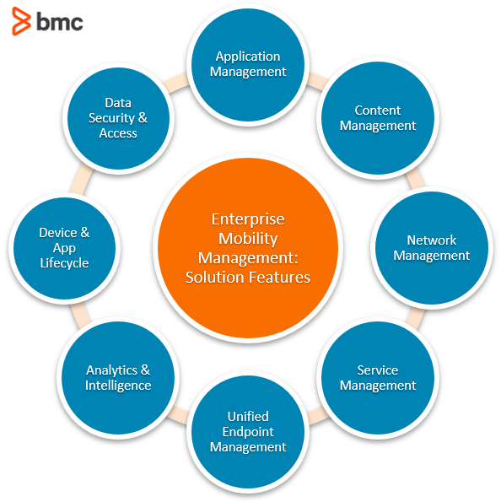2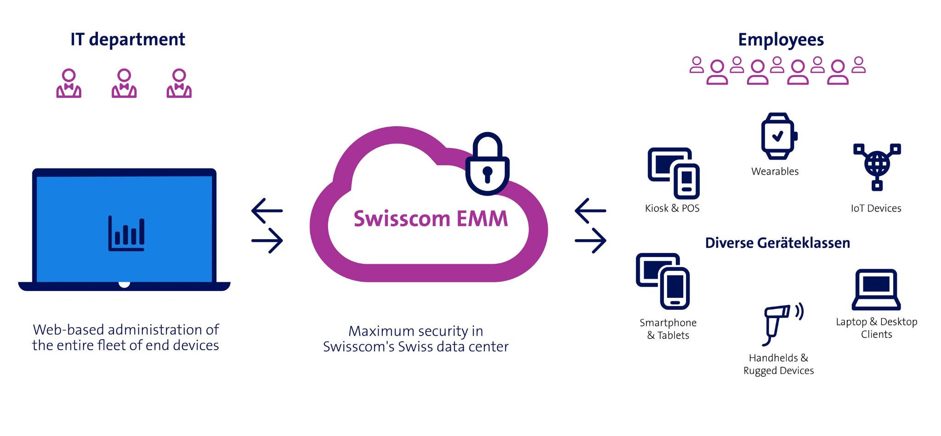
EMM even extends beyond just devices and digital access. In some cases, it ties into systems like building access. Because EMM organizes users into groups, it can control who is allowed to enter certain spaces and when. For example, a student may be allowed to access the building shortly before school starts, while access after hours is restricted. At the same time, staff such as administrators or janitorial staff may have extended access based on their roles.
EMM works by connecting devices, user accounts, and applications onto one network. When a student or staff member logs into a school-issued device using their credentials, the system automatically applies the policies and account settings tied to both the user and the device. With this, things like what apps are available, what websites are blocked, and what settings are enforced are automatically applied to each individual user/ group of users.

Why It Matters in a School
In a school setting like where I work, EMM creates the structured and secure digital environment that is crucial to both learning and safety. Students and staff rely heavily on school-issued devices, and without proper management, those devices could easily be misused or exposed to harmful content.
Beyond general security, there are also legal and organizational responsibilities. Schools are responsible for protecting student data and ensuring appropriate internet use. This includes sensitive information, such as student records or IEPs (Individualized Education Programs). Without systems like EMM in place, it would be much harder to enforce these protections consistently and could put the organization at risk.
EMM allows IT staff to apply rules across all users remotely while still allowing flexibility when needed. For example, a teacher and a teaching assistant (TA) may use the same device, but their access levels are very different. A teacher may have access to confidential student information, while a TA does not. EMM ensures that each user only has access to what they need for their role, reducing both legal and ethical risks.

Real-World Example
In my role working IT at a high school, I use EMM every day when managing devices and user access. If a student runs into an error when trying to open a website or install an application, it is usually because of a policy applied through the system. Instead of physically checking the device, I can review the user’s permissions and quickly identify what is causing the issue.
The same applies to staff. If a teacher needs access to a new tool or program, they can submit a request for it to be approved. Once that tool is reviewed and approved, permissions can be updated through the system and applied instantly, without ever needing to handle the device itself. This makes it possible to manage hundreds of devices efficiently while still customizing access for individual users.

Conclusion
Enterprise Mobility Management is the core system behind how many schools and organizations manage technology. EMM combines device control, user management, and security into one system, allowing organizations like schools to support learning through modern technology while maintaining a safe and organized environment. Even though most users don’t even realize it’s there, EMM is critical to how school technology functions every day.

extraword
Wordcount: 660
Image Sources:
[1] https://www.bmc.com/blogs/emm-enterprise-mobility-management/
[2] https://www.swisscom.ch/en/business/enterprise/offer/enterprise-mobile/enterprise-mobility-management.html?srsltid=AfmBOoqVn2AMXevRE3qakDkZzzJE2Sve2Bjhp3r6a37XMBqO7qPgvtUe

